Java Keywords & Identifiers

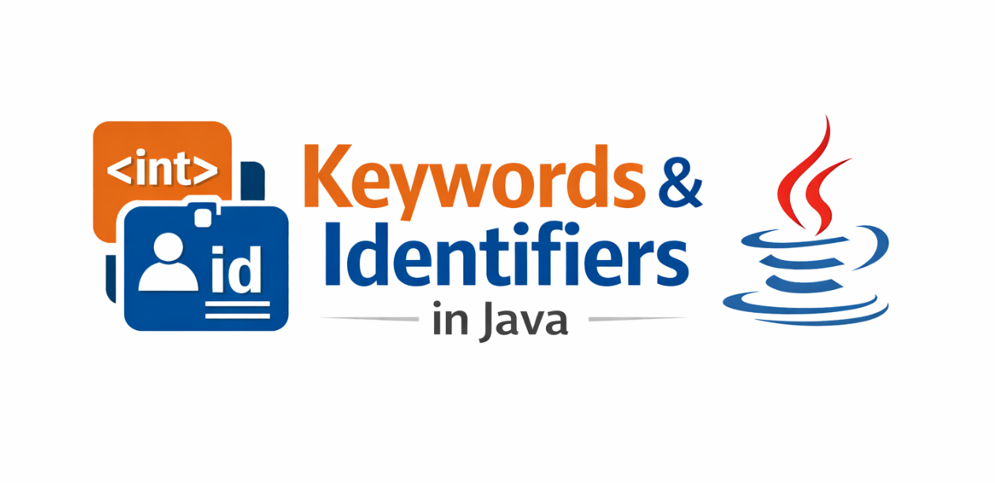

1. Introduction
Java is one of the most popular programming languages in the world. It is widely used for building web applications, enterprise software, Android apps, and large-scale systems.
Before writing complex programs in Java, it is important to understand the basic building blocks of the language.
Two of the most important concepts in Java are:
- Keywords
- Identifiers
These two elements form the foundation of Java syntax.
Every Java program you write will contain identifiers, and every program will rely on keywords defined by the Java language.
Understanding them clearly will help you:
- Write clean and correct Java programs
- Avoid syntax errors
- Understand Java code easily
- Follow good coding practices
In this article, we will deeply understand Java Keywords and Identifiers with examples.

2. What are Keywords in Java?
Definition
Keywords in Java are reserved words that have a predefined meaning in the Java programming language.
These words are part of the Java syntax, and they cannot be used as names for variables, classes, methods, or identifiers.

In simple words:
👉 Keywords are special words that Java already uses for its own functionality.

Example
int number = 10;
Here:
- int → keyword
- number → identifier

Why Java Keywords Exist
Keywords help Java define:
- data types
- control statements
- loops
- class structures
- object-oriented features
Without keywords, Java would not understand how a program should behave.

3. Characteristics of Java Keywords
Java keywords have the following properties:
1. Reserved Words
Keywords are reserved for Java language syntax.
Example:
int class = 10; // ❌ invalid
Because class is a keyword.

2. Cannot be used as identifiers
You cannot use keywords as:
- variable names
- method names
- class names
- object names
Example:
int if = 20; // ❌ not allowed

3. Lowercase in Java
Most Java keywords are written in lowercase.
Example:
class
public
static
void

4. Fixed Meaning
Each keyword has a specific meaning defined by Java.
You cannot change its behavior.

4. Total Number of Keywords in Java
Java currently has 50 reserved keywords.
Examples include:
abstract
assert
boolean
break
byte
case
catch
char
class
const
continue
default
do
double
else
enum
extends
final
finally
float
for
goto
if
implements
import
instanceof
int
interface
long
native
new
package
private
protected
public
return
short
static
strictfp
super
switch
synchronized
this
throw
throws
transient
try
void
volatile
while
Note:
const and goto are reserved but not used.

5. Categories of Java Keywords
Java keywords can be grouped based on their purpose.

6. Data Type Keywords
These keywords define primitive data types.
Examples:
byte
short
int
long
float
double
char
boolean
Example program:
public class DataTypeExample {
public static void main(String[] args) {
int age = 25;
double salary = 50000.50;
char grade = 'A';
boolean isPassed = true;
System.out.println(age);
System.out.println(salary);
System.out.println(grade);
System.out.println(isPassed);
}
}

7. Access Modifier Keywords
These keywords control visibility of classes, methods, and variables.
Examples:
public
private
protected
Example:
public class Student {
private int id;
protected String name;
}

8. Control Flow Keywords
These keywords control program execution flow.
Examples:
if
else
switch
case
default
break
continue
Example:
int number = 10;
if(number > 0){
System.out.println("Positive number");
}
else{
System.out.println("Negative number");
}

9. Loop Keywords
Loops allow repeating a block of code.
Examples:
for
while
do
Example:
for(int i = 1; i <= 5; i++){
System.out.println(i);
}

10. Class Related Keywords
These keywords are used in object-oriented programming.
Examples:
class
extends
implements
interface
super
this
new
Example:
class Animal{
void sound(){
System.out.println("Animal makes sound");
}
}

11. Exception Handling Keywords
Java provides special keywords for handling errors.
Examples:
try
catch
finally
throw
throws
Example:
try{
int result = 10 / 0;
}
catch(Exception e){
System.out.println("Exception occurred");
}

12. Other Important Keywords
Some other important keywords include:
static
final
abstract
synchronized
volatile
native
transient
Example:
final int number = 10;
Here the value cannot be changed.

13. What are Identifiers in Java?
Definition
An identifier is the name given to a variable, method, class, or object in Java.
Identifiers are used to identify programming elements.

Example
int age = 25;
Here:
- int → keyword
- age → identifier

14. Types of Identifiers in Java
Identifiers can represent:
1. Class Names
class Student
Student is an identifier.

2. Variable Names
int marks;
marks is an identifier.

3. Method Names
void display()
display is an identifier.

4. Package Names
package com.example;
example is an identifier.

15. Rules for Identifiers in Java
Java has strict rules for naming identifiers.

Rule 1: Must start with letter, underscore, or $
Valid examples:
name
_age
$salary
Invalid:
1name

Rule 2: Cannot start with number
int 1number; ❌

Rule 3: Cannot use Java keywords
int class = 10; ❌

Rule 4: No special symbols
Invalid:
int total-amount ❌

Rule 5: Case Sensitive
age
Age
AGE
All are different identifiers.

16. Examples of Valid Identifiers
name
studentId
totalMarks
salaryAmount

17. Examples of Invalid Identifiers
1name
class
total-marks
int

18. Naming Conventions in Java
Good programmers follow naming conventions.

Class Naming
Use PascalCase
StudentDetails
EmployeeData
BankAccount

Variable Naming
Use camelCase
studentName
totalMarks
accountBalance

Constant Naming
Use UPPERCASE
MAX_VALUE
MIN_VALUE

19. Keywords vs Identifiers
Purpoes | Keywords | Identifiers
Meaning | Reserved words | Names given by programmer
Usage | Define language syntax | Identify variables, classes
Example | int, class, public | age, student, total

20. Example Program Using Keywords & Identifiers
public class Student {
int id;
String name;
public void display(){
System.out.println(id);
System.out.println(name);
}
public static void main(String[] args){
Student s1 = new Student();
s1.id = 101;
s1.name = "Omkar";
s1.display();
}
}
Keywords used:
public
class
int
void
static
new
Identifiers used:
Student
id
name
display
s1

21. Common Mistakes Beginners Make
1️⃣ Using keywords as variable names
int class = 10;
2️⃣ Starting identifiers with numbers
int 1value;
3️⃣ Using spaces in identifiers
int total marks;

22. Best Practices
✔ Use meaningful names
✔ Follow camelCase naming
✔ Avoid very long names
✔ Keep identifiers readable
Example:
Good:
studentAge
Bad:
sa

23. Conclusion
Keywords and identifiers are two fundamental elements of Java programming.
Keywords define the structure and rules of the language, while identifiers allow programmers to name and manage program elements.
Understanding these concepts clearly helps developers:
- write clean code
- avoid syntax errors
- follow good programming practices
Mastering these basics is the first step toward becoming a strong Java developer.

